|  |  |
| --- | --- |
| DATE | 18 November 2022 |
| TEAM ID | PNT2022TMID45483 |
| PROJECT NAME | Project-Signs with smart connectivity for better road safety |
| PROJECT PHASE DEVELOPMENT | Sprint 4 |

**API FLOW**

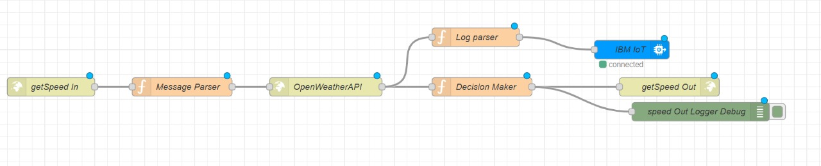

**AUTHORITY GIVING TAKE LEFT DIRECTION**

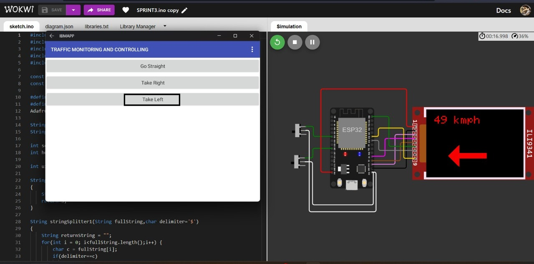

**AUTHORITY GIVING TAKE RIGHT DIRECTION**

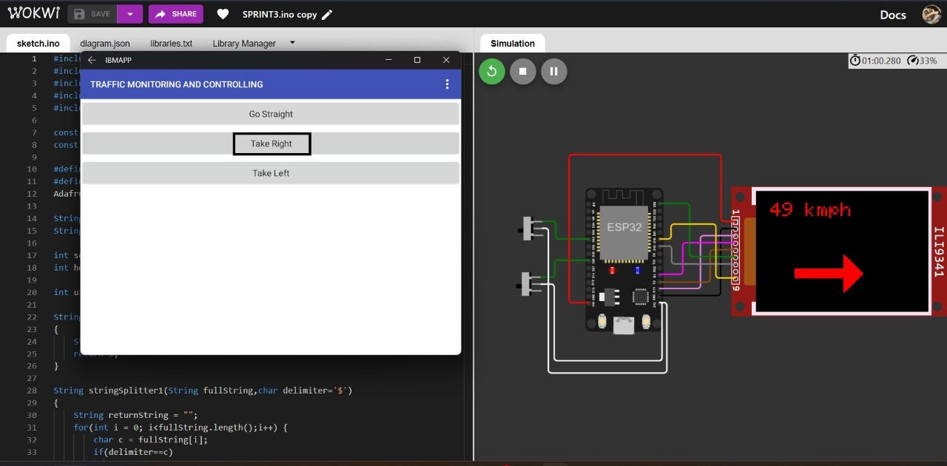

**AUTHORITY GIVING TAKE STRAIGHT DIRECTION**

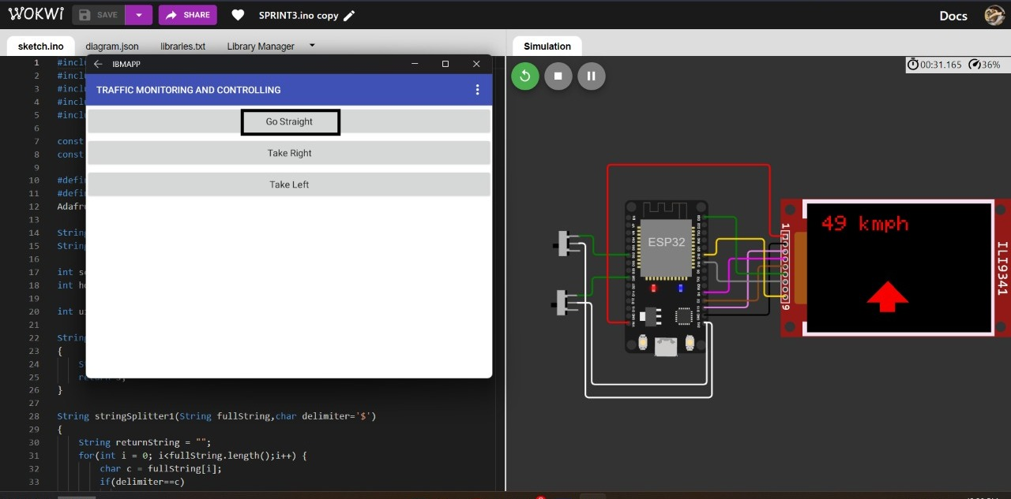

**DASHBOARD**

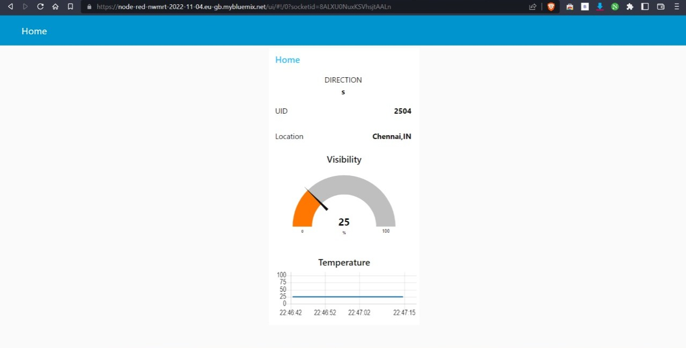

**DIRECTION FLOW**

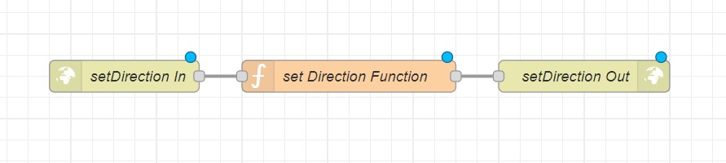

**ESP32 CIRCUIT DIAGRAM**

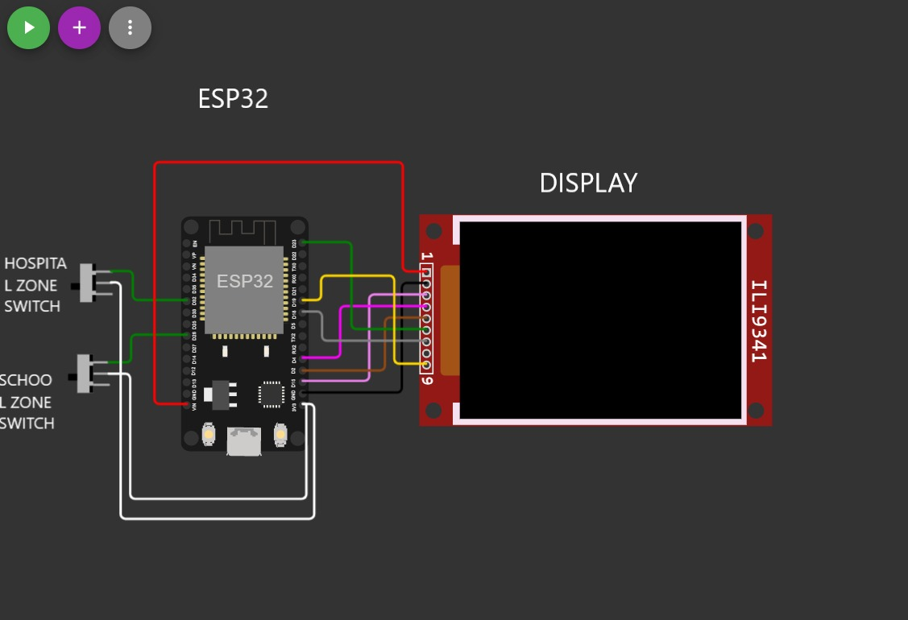

**IOT UI FLOW**

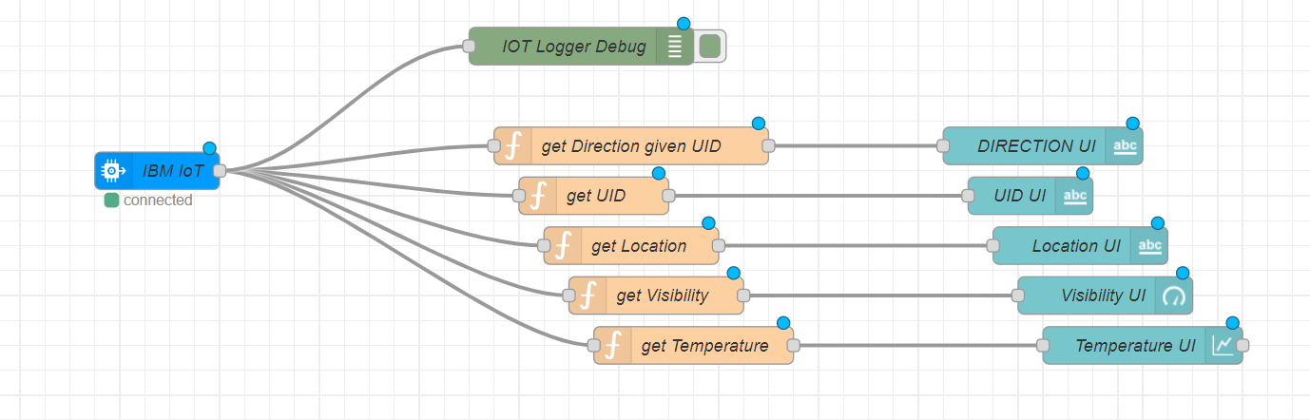

**MIT APP BLOCK CODE FOR MANAGING TRAFFIC**

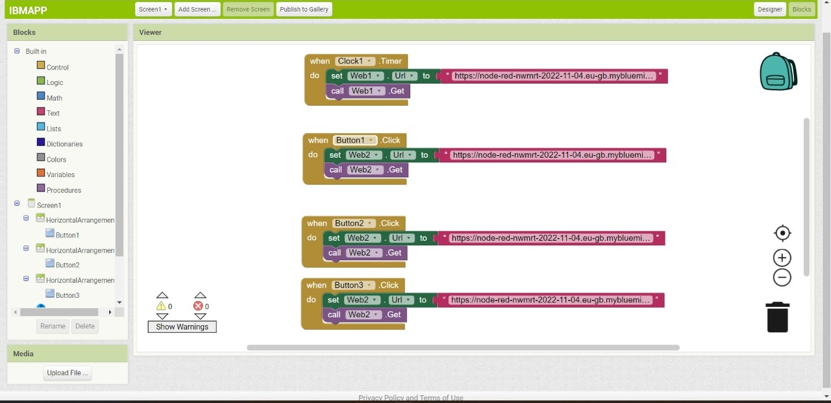

**MIT APP UI FOR AUTHORITY**

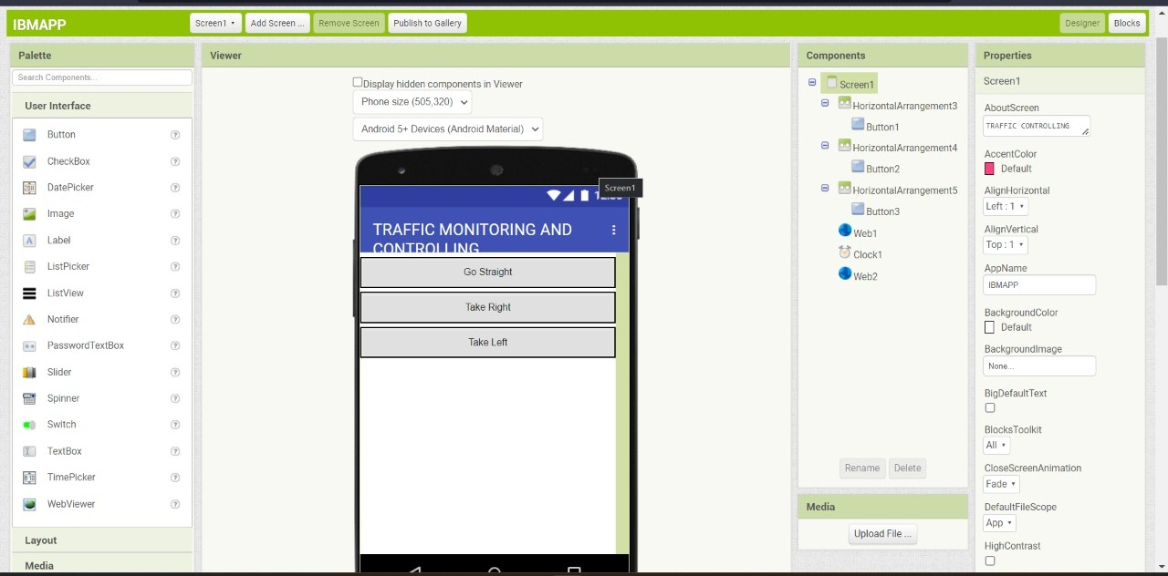

**OVER ALL NODE RED FLOW**

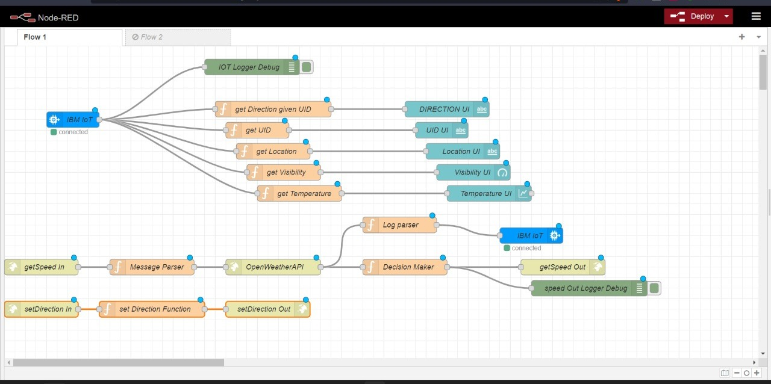

**DATA FLOW**

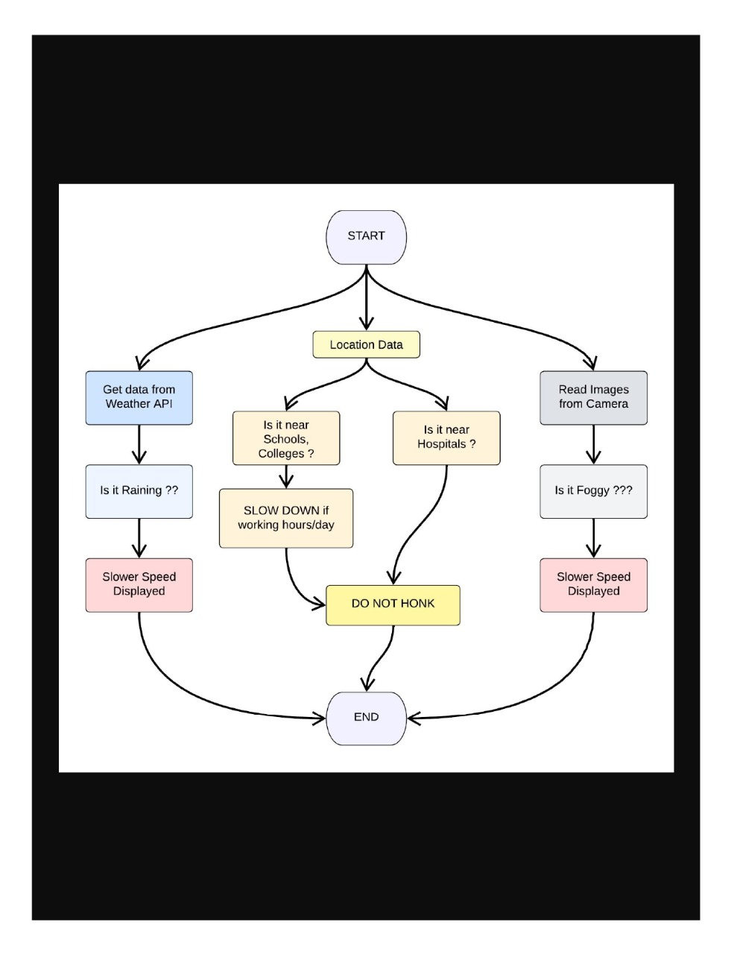

**MAIN.UNO**

**#include <WiFi.h>**

**#include <HTTPClient.h>**

**#include <Adafruit_GFX.h>**

**#include <Adafruit_ILI9341.h>**

**#include <string.h>**

**const char* ssid = "Wokwi-GUEST";**

**const char* password = "";**

**#define TFT_DC 2**

**#define TFT_CS 15**

**Adafruit_ILI9341 tft = Adafruit_ILI9341(TFT_CS, TFT_DC);**

**String myLocation = "Chennai,IN";**

**String usualSpeedLimit = "70"; // kmph**

**int schoolZone = 32;**

**int hospitalZone = 26;**

**int uid = 2504;**

**String getString(char x)**

**{**

**String s(1, x);**

**return s;**

**}**

**String stringSplitter1(String fullString,char delimiter='$')**

**{**

**String returnString = "";**

**for(int i = 0; i<fullString.length();i++) {**

**char c = fullString[i];**

**if(delimiter==c)**

**break;**

**returnString+=String(c);**

**}**

**return(returnString);**

**}**

**String stringSplitter2(String fullString,char delimiter='$')**

**{**

**String returnString = "";**

**bool flag = false;**

**for(int i = 0; i<fullString.length();i++) {**

**char c = fullString[i];**

**if(flag)**

**returnString+=String(c);**

**if(delimiter==c)**

**flag = true;**

**}**

**return(returnString);**

**}**

**void rightArrow()**

**{**

**int refX = 50;**

**int refY = tft.getCursorY() + 40;**

**tft.fillRect(refX,refY,100,20,ILI9341_RED);**

**tft.fillTriangle(refX+100,refY-30,refX+100,refY+50,refX+40+100,refY+10,ILI9341_RED);**

**}**

**void leftArrow()**

**{**

**int refX = 50;**

**int refY = tft.getCursorY() + 40;**

**tft.fillRect(refX+40,refY,100,20,ILI9341_RED);**

**tft.fillTriangle(refX+40,refY-30,refX+40,refY+50,refX,refY+10,ILI9341_RED);**

**}**

**void upArrow()**

**{**

**int refX = 125;**

**int refY = tft.getCursorY() + 30;**

**tft.fillTriangle(refX-40,refY+40,refX+40,refY+40,refX,refY,ILI9341_RED);**

**tft.fillRect(refX-15,refY+40,30,20,ILI9341_RED);**

**}**

**String APICall() {**

**HTTPClient http;**

**String url = "https://node-red-nwmrt-2022-11-04.eu-gb.mybluemix.net/getSpeed?";**

**url += "location="+myLocation+"&";**

**url += "schoolZone="+(String)digitalRead(schoolZone)+(String)"&";**

**url += "hospitalZone="+(String)digitalRead(hospitalZone)+(String)"&";**

**url += "usualSpeedLimit="+(String)usualSpeedLimit+(String)"&";**

**url += "uid="+(String)uid;**

**http.begin(url.c_str());**

**int httpResponseCode = http.GET();**

**if (httpResponseCode>0) {**

**String payload = http.getString();**

**http.end();**

**return(payload);**

**}**

**else {**

**Serial.print("Error code: ");**

**Serial.println(httpResponseCode);**

**}**

**http.end();**

**}**

**void myPrint(String contents) {**

**tft.fillScreen(ILI9341_BLACK);**

**tft.setCursor(0, 20);**

**tft.setTextSize(4);**

**tft.setTextColor(ILI9341_RED);**

**//tft.println(contents);**

**tft.println(stringSplitter1(contents));**

**String c2 = stringSplitter2(contents);**

**if(c2=="s") // represents Straight**

**{**

**upArrow();**

**}**

**if(c2=="l") // represents left**

**{**

**leftArrow();**

**}**

**if(c2=="r") // represents right**

**{**

**rightArrow();**

**}**

**}**

**void setup() {**

**WiFi.begin(ssid, password, 6);**

**tft.begin();**

**tft.setRotation(1);**

**tft.setTextColor(ILI9341_WHITE);**

**tft.setTextSize(2);**

**tft.print("Connecting to WiFi");**

**while (WiFi.status() != WL_CONNECTED) {**

**delay(100);**

**tft.print(".");**

**}**

**tft.print("\nOK! IP=");**

**tft.println(WiFi.localIP());**

**}**

**void loop() {**

**myPrint(APICall());**

**delay(100);**

**}**

**PROCESS FLOW**

